

Directorate for Admissions and Academic Records
Mobile Phone : (+250)724 796 996 / 724 474 805/ 788 473 035
Email: registrar@auca.ac.rw, || juvenal.nsengiyumva@auca.ac.rw

Kigali, April 28, 2026

CERTIFICATE OF GOOD STANDING

I, the undersigned, Eng. Nsengiyumva Juvenal, Director for Admissions and Academic Records of the Adventist University of Central Africa, hereby certify that:
Tuyizere Dieudonne,
Born on June 12, 2006
has been a regular student of this University, registered under ID No. 2025SEN349,
From January 2026 to Date.
Year: One (Semester 1)
Faculty: Information Technology
Major: Software Engineering
Academic year: 2025-2026 (September 2025-August 2026)
Validity: September 2025-August 2026

This certificate is issued for any legal or administrative purpose it may serve

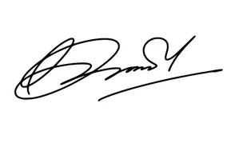

________________________________________
Eng. Nsengiyumva Juvenal
Director for Admissions and Academic Records
Adventist University of Central Africa
Scan to verify my Validity

